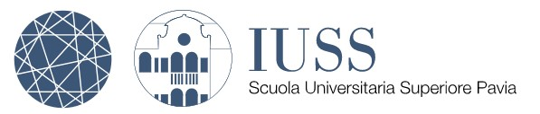

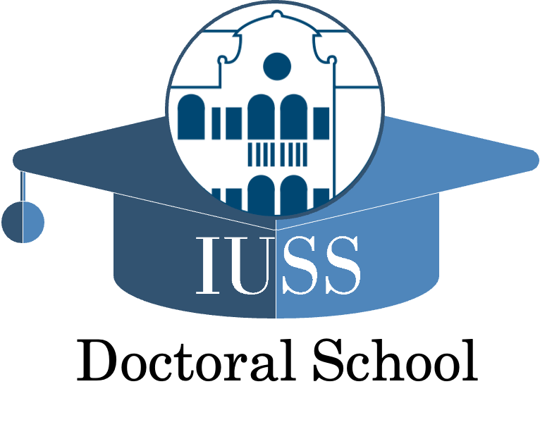

Seminars Series “A lesson in…”
IUSS Doctoral School

A Lesson in …
Drugs of abuse and psychiatric disorders
Roberto Cavallaro
Vita-Salute San Raffaele University

January 26th 2026, 2.30 PM
Sala Conferenze, Palazzo Broletto
Piazza della Vittoria n. 15, Pavia

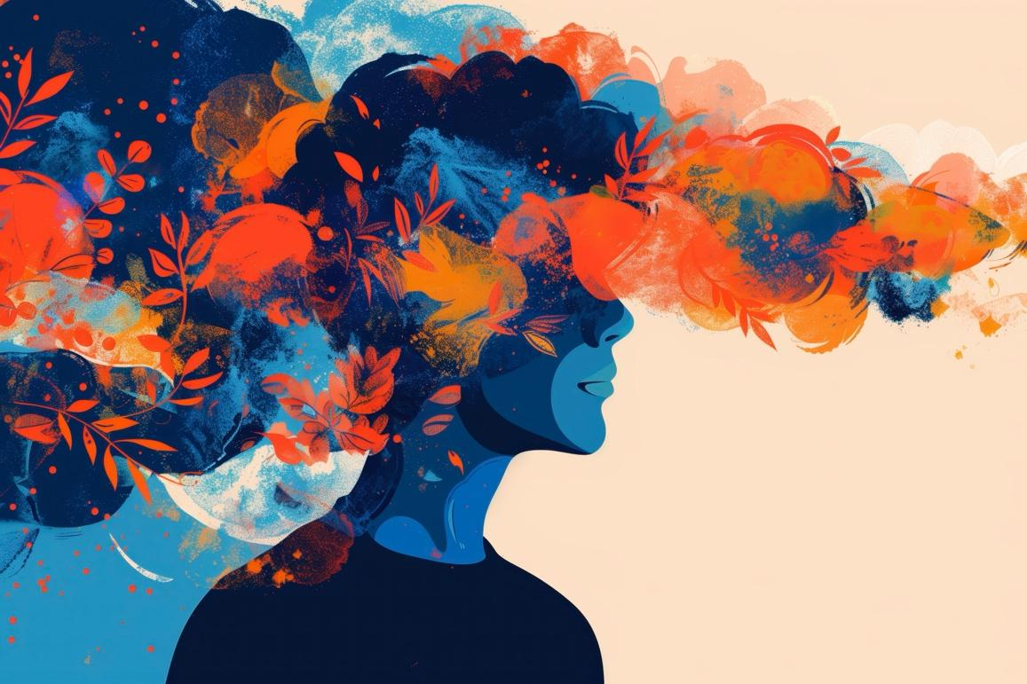

More info:
postlaurea@iusspavia.it

